Trustee

Information Pack 2025

Author: Martyn Balson

Date: February 2025

# **I** Contents

Welcome to Lighthouse 3

Your application 5

Role of trustee 6

Our board 8

Our history 9

Our vision, mission & values 10

Strategic goals 11

Our structure 18

# **I** Welcome to Lighthouse

Lighthouse is the largest regional arts centre in the UK and the leading cultural venue in Dorset, presenting nationally acclaimed arts and community engagement locally from our home in

Poole and the BCP (Bournemouth, Christchurch, and Poole) region.

Lighthouse provides a year-round programme of high quality and diverse arts and entertainment from national, international, and regional artists, providing the community with opportunities to engage in a broad range of arts activities and experiences. Primarily a receiving venue, the variety and varying size of our spaces enables us to present a huge range of work

from all art forms and scale – from high profile artists to those starting out, from commercial promoters to small-scale funded artists and companies. We are home to the internationally acclaimed Bournemouth Symphony Orchestra and several arts organisations who use our venue to deliver arts activities and cultural training. Lighthouse is a not-for-profit charitable trust and receives funding from Arts Council England as a National Portfolio Organisation (NPO) and from BCP Council to support its charitable aims.

Lighthouse is committed to a diverse board that promotes equity, diversity and inclusion.

The Chair and I are seeking new board members to support the senior management team to drive our continuing success and fulfil our ambitions for the future.

Whilst we welcome expressions of interest from all candidates, we are particularly keen to hear from applicants with significant experience at a leadership level in:

: Law

: Finance

: Human Resources & People

Trustees undertake a non-executive role, and a minimum term of three years’ commitment is required. Trustees can be re-elected for a second term. Five board meetings will be held across the year and attendance at every meeting is required. An Away Day is held annually in Poole.

Trustees will also be asked to become a member of a small sub-committee that focuses on a particular subject or area such as Finance, HR or Capital. In return, we provide a lively, friendly and interesting place to contribute to, a unique opportunity to help progress an ambitious organisation and of course opportunities to experience many wonderful performances.

We welcome your application.



Elspeth, Chief Executive Officer (CEO)

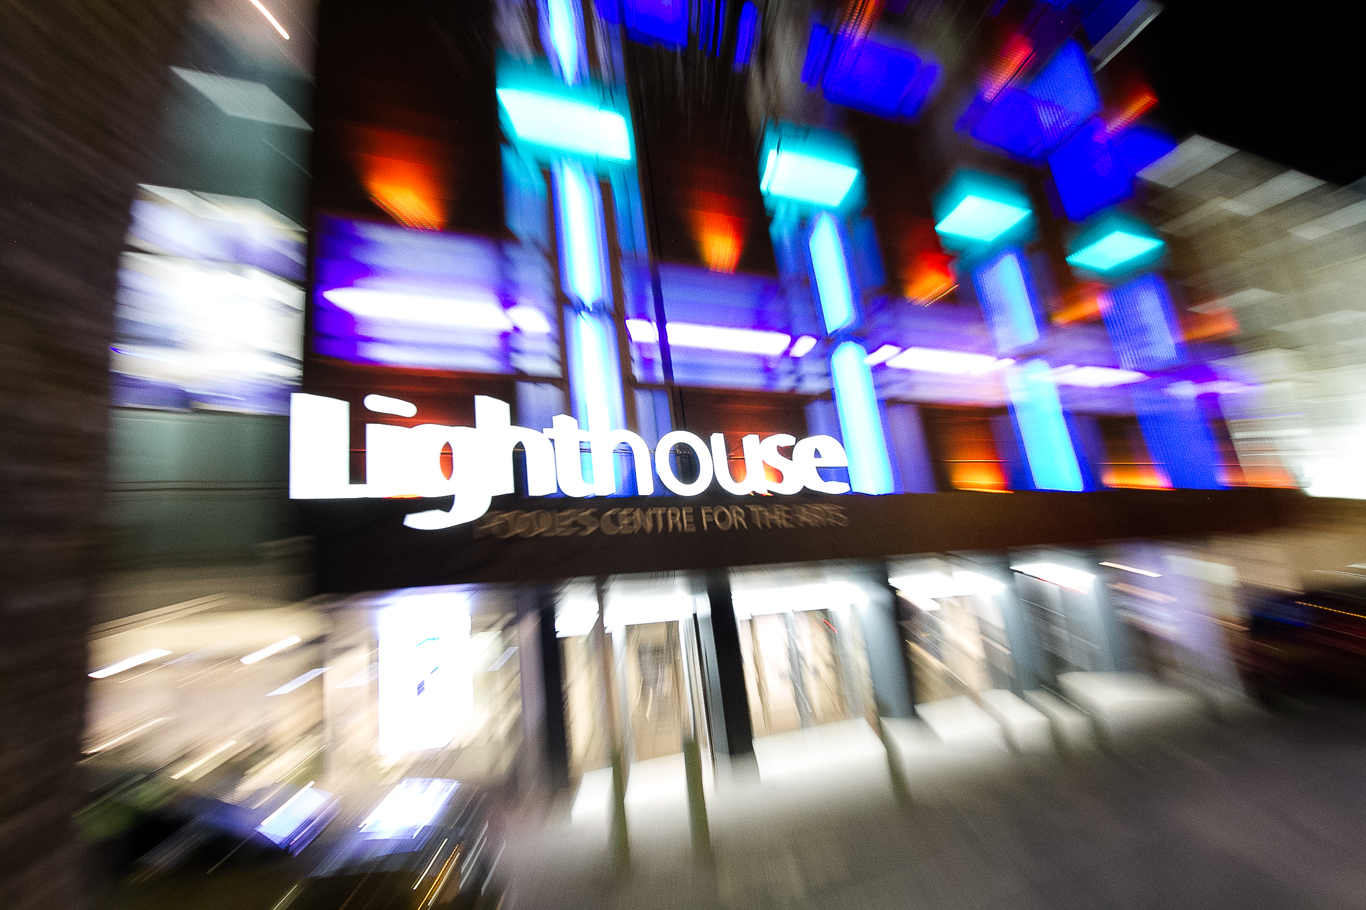

# **I Your application**

Thank you for your interest in becoming a trustee at Lighthouse.

Application process

Please complete the trustee application form in no more than two pages outlining the reasons for your interest in becoming a trustee. You should also demonstrate the skills, expertise and experience you can bring to the role.

Applications should be emailed to

hr@lighthousepoole.co.uk

If you wish to discuss the role further, then please email the HR team who will get in touch with you.

# **I Role of Trustee**

Reporting to: Chair of Board

Department: Board

Term of office: Three years with option for a further term

Remuneration: This is a voluntary role

Principle purpose of the role

To act as trustee of the organisation, ensuring that the company operates in line with its charitable objectives and legal and financial parameters. As a board member, set the policy framework and strategy in which Poole Arts Trust Ltd. operates and monitor its implementation. Represent Poole Arts Trust Ltd. to national, regional and local stakeholders.

Planning & Delivery

* Shape and support the company’s mission and purpose.
* Ensure that the company operates with legal and ethical integrity. Ensure the company operates within the law and in line with its fiscal responsibilities.
* Attend and participate at board meetings and to contribute and share responsibility for the board’s decisions.
* Uphold the values, objectives and core policies of Poole Arts Trust Ltd.
* Support the Chief Executive to further the goals of the company and assess his/ her performance.
* Enhance the company’s public standing by communicating its goals, mission and activities to the wider community.
* Represent Poole Arts Trust Ltd. at performances, meetings and events, as and when required.
* Responsible for the recruitment of the Chief Executive. Also, responsible for the recruitment of additional board members and their induction onto the Board of Trustees.
* Participate within any board committees that the Chair requires for the purposes of delivering any of the company’s objectives.
* Monitor the organisational planning process and the achievement of plans against goals.
* Monitor the artistic programme and services offered, to ensure they are effective and in line with the mission.
* Contribute any particular expertise wherever applicable by participating fully in meetings and assisting the board on special projects where your specific knowledge and skill may be of use.

Communication

* Promote and communicate the company’s values and culture to both internal and external customers.

Finance

* Approve the annual budget and ensure appropriate financial controls are in place.

Health & Safety

* Be responsible for ensuring the correct management of health & safety, as laid down in legislation and in line with the company’s policies and procedures.

Representation

* Represent the company at performances, meetings and events, as and when required.

EDIB

* Embrace and promote equity, diversity, inclusion and belonging at Lighthouse, living our commitment statement.

Values

* Promote and communicate the Lighthouse values and culture.

# **I Our Board**

Board Members

MT Rainey Chair

Monika Barnes Deputy Chair

Jane Webster Chair of Finance Sub-Committee

Spencer Clarke

Channa Vithana

David Hoare

Ali Gannage-Stewart Health & Safety / Sustainability Lead

Caroline Gitsham

Tony Johnson

Board Sub-Groups

Finance Sub-Committee

Executive

Elspeth McBain Chief Executive Officer

Pete Wilson Head of Finance

Martyn Balson General Manager

John Baker Head of Audiences & Communications

Katy Griffiths Head of Programming

Sue Lloyd Head of Development

'As a Board we focus on supporting the success and sustainability of this wonderful cultural asset. In increasingly challenging times this means scrutinising all aspects of organisational viability with a medium to long term lens, as well as ensuring that the day-to-day activities deliver for audiences, staff and the objectives of The Arts Council. A vibrant and busy programme means that it’s always a pleasure to visit and meet at Lighthouse.'

MT Rainey, OBE.

# **I Our History**

Lighthouse started life as a big ambition to inject culture into the Poole community and forty-seven years later our big ambitions are still going strong.

Opened in 1978 as Poole Arts Centre, we were created in response to a lack of cultural facilities in South East Dorset. Conceived, designed and delivered by an ambitious local authority keen to invest in cultural

provision for its community the Centre was unrivalled in the region for the opportunities it presented to experience such breadth and quality all under one roof.

Poole Arts Trust was set up as a company limited by guarantee and registered as a charity, with a board of voluntary directors to operate and manage the venue. The trust was and still is linked to the Borough of Poole, (now BCP Council) through the provision of financial support. The trust is the leaseholder of the building with BCP Council as the freeholder.

In 1998 Lighthouse attracted its first revenue funding from Arts Council England and first started undertaking education work in order to increase its impact and value it added to the community.

Having celebrated its 21st year of operation in 1999 the venue underwent a £9.5 million transformation to bring the facilities up to date technically and to upgrade the public areas. Re-opened in October 2002, the centre was reborn as Lighthouse, Poole’s Centre for the Arts.

During the summer of 2017 a programme of capital works delivered a range of improvements across the building including the transformation of the Sherling Studio, the main entrance moved to a central position with clear glazing installed in the foyer, the creation of a new education and rehearsal space, upgrades to sound, light and digital technology, a new stage door entrance, updated dressing rooms, a Green Room and improved security. Lighthouse is proud to be the home venue of Bournemouth Symphony Orchestra.

# **I** Our Vision, Mission & Values

# I Strategic Goals

Goal 1: Delivering a Wide-Ranging and Great Arts Programme

Arts Council Investment Principle: Ambition & Quality; Inclusivity & Relevance

Arts Council Outcome: Creative & Cultural Country

As one of the largest combined arts centres in the UK, Lighthouse is committed to maintaining a wide breadth of high-quality, professionally produced cultural experiences. There are four distinct auditoria within Lighthouse and an open-air amphitheatre space adjacent to the building.

Our Concert Hall presents predominantly single night engagements, mainly music or comedy, that wrap around the BSO rehearsal and performance programme, as well as commercial events such as conferences, exhibitions and dinners.

Our Theatre presents longer runs of theatre and dance, our annual pantomime and one-night performances of music and comedy, circus and spoken word.

The Sherling Studio is used for music, theatre, and comedy, mainly within clearly defined series such as Studio Jazz, Live and Unheard and Coastal Comedy. It is also an ‘incubation space’ for artists and companies to develop their creation process.

We operate the only independent cinema in the local area, programmed by Picture House Group, and recent investment in cinema facilities within our theatre space allows an expansion of this provision at times when our theatre stage is not programmed for live productions.

We curate a programme of visual art in our gallery spaces, offering both professional and community artists and schools access to exhibit. Lighthouse’s digital provision is still in its early stages, but we are committed to developing this to expand audience access and extend reach.

The target for this business plan will be to maintain a steady level of presented work that will generate a financial surplus where appropriate and focus on increasing attendance rather than increasing the number of shows we programme.

Goal 2: Retaining, Building, Diversifying and Growing Audiences

Arts Council Investment Principle: Dynamism; Inclusivity & Relevance

Arts Council Outcome: Cultural Communities

We anticipate that ticket sales will return to pre-pandemic levels from 2023/2024 and from there we will aim to increase both volume and, most importantly, yield to ensure financial stability and future sustainability, with an objective to achieve annual (paid) audience figures of 230,000 by 2027. We listen to our audiences and artists and design our work to be inclusive, relevant and of the highest quality.

We aim to increase the volume and/or frequency of attendance to achieve an annual increase in volume and demand, and to increase our average annual ticket yield by at least inflation, and our capacity to 60% across the organisation. While each of the auditoria has its own benchmarks for capacity, the average in recent years for the whole venue is 50%. We think this should be no lower than 60% and the organisation will work steadily over the next five years to achieve this, with a target of a 2% increase in the proportion of available tickets sold. Because of the structure of many co-promotion deals, every 1% increase in capacity can have a benefit that goes straight to the bottom line.

We will focus on retention of existing audiences, increasing frequency of attendance, introducing new audiences to our programme, and then developing a regular connection.

We strive to attract a diverse audience, particularly in terms of race, age, and socio-economic demographic through the programme we offer, as well as the way that we communicate and welcome diverse communities into our venues.

Lighthouse has traditionally been ‘show-centric’ with communication focussed on selling shows. This is driven by the human and financial resources available, the deals we strike with promoters, and sales targets. As a multi-function arts centre, it is vital we consider the whole picture to support the brand and create strong recognition and understanding of who we are to communicate our business plan.

Building positive perception and awareness of Lighthouse within and beyond the catchment area and from diverse sections of our community will improve our visibility, communication and interaction with our community, the national arts sector, customers, and potential customers.

We invest in audience research and analysis to deepen our understanding of our core audiences and their key motivations and to gain a deeper understanding of the drivers to attract new audiences.

Goal 3: Developing Creative People Through Lighthouse Academy

Arts Council Investment Principle: Ambition & Quality; Inclusivity & Relevance

Arts Council Outcome: Creative People

Lighthouse has always invested in developing artists and creative people and, during the 2020/2021 pandemic, refocussed on the sector which has been so harshly affected. This priority outlines our commitment to increasing our support for the cultural sector, and specifically for performers and creative practitioners, through a dedicated programme of support, opportunity, and development.

We are uniquely positioned to do this because of our reputation and reach, our location in BCP/South West and because of the range and variety of our artistic programme.

Lighthouse Academy is the new vehicle that will provide a clearly defined and dynamic programme of learning for our community on a scale unseen anywhere in the region. The Academy will ensure that the young people of Poole and the BCP region can access diverse arts and cultural experiences, creative development and off-stage training, and explore, consider, and develop careers in the creative industries without having to leave the region. It will provide support for artists to develop and grow their practice and will support our own staff teams to develop and extend their knowledge and skills base.

Currently the Government prioritises STEM subjects over arts and creative studies, resulting in a potential loss of young people in the sector pipeline. Lighthouse’s scale, breadth of programming and location in the BCP/Southwest region creates a unique opportunity to address some of that gap and to impact positively on people at all stages of their careers.

By bringing together artists, staff, audiences, and community development we aim to enhance and expand learning opportunities that will have economic and social impact, increase employment opportunities, and deliver better outcomes for all participants.

We support partner organisations to provide learning and participation opportunities and provide partner schools with opportunities to enable their students to have access to culture.

The programme is developed under three distinct strands:

1. Learning and Participation

2. Artist Development

3. Lighthouse Family

**Goal 4: Connecting with Our Community**

**Arts Council Investment Principle: Ambition & Quality; Inclusivity & Relevance; Dynamism**

**Arts Council Outcome: Cultural Community**

Lighthouse provides a significant range of opportunities for people of all backgrounds within our community to take part in a wide range of cultural activities and see inspiring, entertaining, thought-provoking, and exciting performances through a high-quality cultural programme. Our audiences are engaged, curious and eager to get closer to the artists, the creation process and the ideas that are presented. The pandemic increased our resolve to ensure that Lighthouse is relevant to, and provides opportunities for and within, our community. We offer unique opportunities to engage with the artists and creatives who make this work and develop a deeper understanding of the arts.

We are mindful that while we have some projects that are delivered away from the actual building, most of our work has been contained to activities within the venue and to the many regular arts organisations that use it. We are actively expanding our outreach programme as we are committed to responding to the needs of our community, extending the activities that we offer and developing new connections and collaborations with communities that we have not yet had links with, as well as the diverse communities which have an established cultural programme across the BCP region.

Our aim is that Lighthouse will be the creative heart of the local community through a broad and far-reaching cultural provision that is relevant, targeted and particularly supports young people to connect with cultural activities and experiences.

Goal 5: Improving Equity, Diversity, Inclusion and Belonging

Arts Council Investment Principle: Inclusivity & Relevance

Arts Council Outcome: Cultural Community

The arts sector is now actively confronting the inequalities that exist within it, particularly around race and disability. Lighthouse has a responsibility to ensure that representation from the wider UK demographic is seen within the Board, staff and volunteers as well as the artists and creatives it presents and engages.

Lighthouse recently commissioned an independent review into its inclusion of, and engagement with, people from ethnically diverse backgrounds, including staff, volunteers, audiences and stakeholders. The review consisted of analysing current strategic documents and policies, one-to-one interviews with internal and external stakeholders, anonymous staff surveys, and exploratory workshops with both staff and the charity’s Board. The independent analysis and recommendations will provide a robust springboard to develop the organisation’s strategic action plan for equity, diversity, inclusion and belonging (EDIB).

Goal 6: Maintaining a World Class Facility

Arts Council Investment Principle: Dynamism

Arts Council Outcome: Cultural Community

We are committed to maintaining a world-class facility and providing greater access, sustainability, and inclusivity for our audiences, artists, and colleagues. Lighthouse needs to remain competitive and relevant amongst its peers and partners. The health, safety and wellbeing of all who use this public building is paramount, and ensuring that the building is well-maintained and adheres to all legislation is critical to achieve safe practices. It must emulate our values of Excellence and Welcome. There have been several areas of capital improvement in recent years, including digital infrastructure and a cinema installation in the theatre, to provide avenues for further income generation.

The building has an ongoing planned maintenance programme to maintain the building in good order and account for small-scale unplanned maintenance as things get damaged or fail. Over the coming period, we will work towards creating greater access and inclusivity for all across the building.

We continue to develop our building and external realm with a £750k five-year plan in place to cover planned maintenance and capital improvements and investment in refurbishment.

Future larger capital developments will link with the cultural ambition for the region and the plans for regeneration in the town. Our ambition is that Lighthouse is a ‘destination venue’ with benefit for employment and the local community, by virtue of the investment in place-making that the regeneration work would represent. A 10-year master plan will set out the longer-term vision for the venue itself and this will require significant additional funding of £8-£10m to be found.

The global environmental situation is of continued concern and significance to the artistic community, and we are conscious of our responsibility to play our part in addressing this issue.

Goal 7: Financial Resilience

Arts Council Investment Principle: Ambition & Quality/Dynamism

Arts Council Outcome: Cultural Community

We have a rigorous approach to financial planning; we are taking an entrepreneurial

approach to developing and optimising our income streams. We have a structured approach to business forecasting and planning that involves the whole organisation.

The underlying approach has been articulated by the Board as having *‘a commercial head and an artistic heart’*. The organisation’s ambition is to continually seek new ways of enabling its artistic work through a fundamentally healthy financial position, and be financially sustainable by carefully balancing our finances between artistic risk and our charitable purposes, taking a commercial approach to present our artistic objectives, seeking funding to support earned income.

Lighthouse will continue to exercise firm and detailed control on its finances to ensure that wherever possible funds are available to weather economic shocks, to allow the organisation to deliver on its strategic priorities, and to maintain the building and organisation in good health for this and future generations.

During the pandemic, Culture Recovery Fund (CRF) funding enabled the organisation to stabilise and rebuild reserves to eight weeks of turnover. Our priority is to increase these further, with eight weeks as a baseline through improved end of year results, achieved through investment, income growth, efficiency, increased fundraising, and continued funding support. We will know if we are successful if these surpluses are delivered under normal trading and there is sufficient cash available to meet the wider strategic objectives of the organisation at the appropriate time.

Whilst the organisation targets financial resilience, it recognises that a key contributing factor is the continued financial support of core funders (ACE and BCP Council) and that, in the context of charitable, not-for-profit endeavour, there is a limit to the amount of absolute resilience that it is practical to achieve.

The organisation also recognises the difficult economic climate in which the first years, at least, of this business plan will be delivered. The compounded shocks of the end of lockdown, the wars in Ukraine and Gaza and their effects on fuel and commodity prices, together with above-cost price inflation by suppliers across the economy, are contributing to inflation at historic highs and a significant cost-of-living crisis.

This strategic priority applies to all areas of the organisation and due consideration of financial risk will be a key part of all our decision-making processes.

Goal 8: Supporting the Cultural Strategy of the Region

Arts Council Investment Principle: Ambition & Quality

Arts Council Outcome: Cultural Community

Lighthouse plays a vital part of the cultural economy of the BCP region as the largest regional arts centre in the UK. It sits as part of a group of innovative arts organisations and venues that together create a vibrant cultural offer for the residents, workers and visitors to the region.

These and other national arts networks have supported each other significantly throughout the last few years, and close and supportive partnership working has become an even more important trait of the region’s cultural landscape. Collectively we will support the recovery of the BCP region and the national arts sector with the cultural programme we present and the connections we have with our community.

This fulfils our mission to be an important national and local venue, connecting to our community and ensuring that audience and artists alike have opportunities to engage with the arts, enhance their creative development and connect with the national cultural sector.

# I Our Structure

