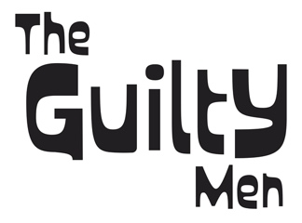

**Debut album Invisible Confetti released 5th September 2024.**

The days of the Supergroup may be long past… but The Guilty Men would surely qualify for that description! The band is made up of five of the finest musicians from the Northwest of England. Between them, they have played over 10,000 gigs on planet Earth, recorded thousands of songs and made countless radio and TV appearances. To say they’re experienced would be an understatement!

The story starts in 1979, in Manchester, England. Clive Gregson and Neil Cossar met through a mutual friend, John Martin, the bassist in The Cheaters… Neil was the band’s guitarist. Clive was the leader of Any Trouble. The Cheaters had a PA, Any Trouble owned a van. It made sense to pool resources, often with both bands on the same bill… happy days!

Any Trouble signed to Stiff Records, The Cheaters signed to EMI. Both bands released several albums and played thousands of shows. Both bands ran their course… Clive then went on to a successful partnership with singer Christine Collister, released over 20 solo albums, and spent 15 years in Nashville working as a session musician and producer. Neil became a radio DJ, formed a Music PR company and launched the online brand This Day in Music, before becoming a music book publisher.

Cut to 2021… lifelong friends Clive and Neil are catching up over lunch and thought it might be fun to try and write some songs together… Several weeks and quite a few songs later, they decided to expand the enterprise from a songwriting workshop to a full blown band. Clive recruited keyboardist Jez Smith and bassist Craig Fletcher from John Lees’ Barclay James Harvest… and the lineup was completed with the addition of legendary drummer, Paul Burgess, who has played with 10cc since 1973. They named the band The Guilty Men… and headed into the recording studio.

Cut to 2024… and The Guilty Men’s debut album “Invisible Confetti” is ready to roll. 13 brand new songs recorded in the old-fashioned way: everybody playing live in the studio, intent on catching the moment. Most of the songs were laid down in no more than 2 or 3 takes… and with four featured lead vocalists, the album covers a lot of musical bases. “Invisible Confetti” rocks… with nods to Americana, country, folk, pop, psychedelia… it’s an exhilarating ride from start to finish. All aboard!