

**The Guilty Men to perform at Poole Lighthouse on UK tour**

30th January

[By Deb Gayen](https://www.bournemouthecho.co.uk/author/profile/321738.Deb_Gayen/)

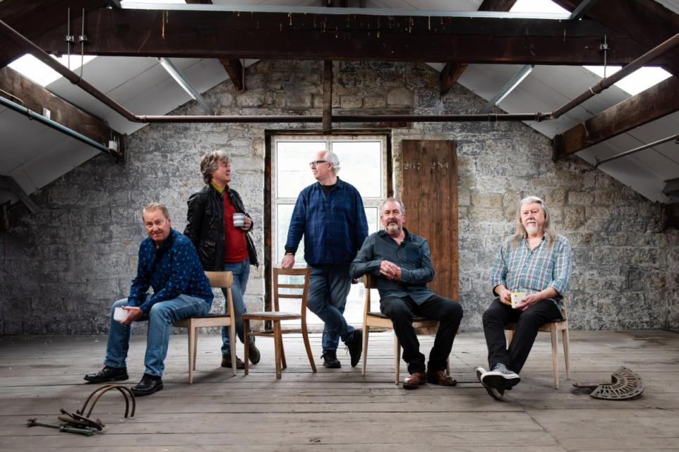

The Guilty Men to perform at 19 UK venues

'Supergroup' The Guilty Men will perform in Poole as part of their UK tour.

The band, who released their debut album *Invisible Confetti* in September 2024, will take to the stage at the Lighthouse on Saturday, March 22.

Formed in 2021 by Clive Gregson (Any Trouble) and Neil Cossar (The Cheaters), the group has played more than 10,000 gigs and made numerous radio and TV appearances.

Keyboardist Jez Smith and bassist Craig Fletcher from John Lees’ Barclay James Harvest and drummer Paul Burgess, who has played with 10cc since 1973, complete the line-up.

A spokesman for the band said: "The days of the supergroup may be long past… but The Guilty Men would surely qualify for that description."

The band's new single, *Dangerous Girl*, will be released in January, complete with a video directed by Adam Dean.

This follows *Susan’s Back Drinking*, which was featured as *Single of the Week* on more than 50 UK radio stations.

The tour will see the group perform at 19 venues across the UK in February and March.