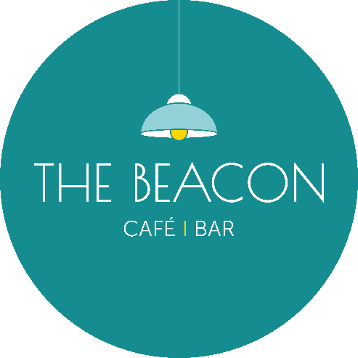

Opening Times – July 2024

|  |  |  |  |
| --- | --- | --- | --- |
| Day | Date | Lunch | Evening |
| Monday | 01.7.24 | ***Closed*** | ***Closed*** |
| Tuesday | 02.7.24 | 10.00-15.00 | ***Closed*** |
| Wednesday | 03.7.24 | 10.00-15.00 | ***Closed*** |
| Thursday | 04.7.24 | 10.00-15.00 | 17.00-20.00 |
| Friday | 05.7.24 | 9.00-15.00 | 17.00-20.00 |
| Saturday | 06.7.24 | 10.00-15.00 | 17.00-20.00 |
| Sunday | 07.7.24 | ***Closed*** | ***Closed*** |
| Monday | 08.7.24 | ***Closed*** | ***Closed*** |
| Tuesday | 09.7.24 | 10.00-15.00 | ***Closed*** |
| Wednesday | 10.7.24 | 10.00-15.00 | ***Closed*** |
| Thursday | 11.7.24 | 10.00-15.00 | 17.00-20.00 |
| Friday | 12.7.24 | 10.00-15.00 | 17.00-20.00 |
| Saturday | 13.7.24 | 10.00-15.00 | 17.00-20.00 |
| Sunday | 14.7.24 | ***Closed*** | *15.00-19.00 |
| Monday | 15.7.24 | ***Closed*** | ***Closed*** |
| Tuesday | 16.7.24 | *10.00-15.00 | *17.00-20.00 |
| Wednesday | 17.7.24 | *10.00-15.00 | ***Closed*** |
| Thursday | 18.7.24 | *10.00-15.00 | ***Closed*** |
| Friday | 19.7.24 | *10.00-15.00 | *17.00-20.00 |
| Saturday | 20.7.24 | *10.00-15.00 | *17.00-20.00 |
| Sunday | 21.7.24 | ***Closed*** | ***Closed*** |
| Monday | 22.7.24 | ***Closed*** | ***Closed*** |
| Tuesday | 23.7.24 | *10.00-15.00 | ***Closed*** |
| Wednesday | 24.7.24 | * 10.00-15.00 | ***Closed*** |
| Thursday | 25.7.24 | *10.00-15.00 | ***Closed*** |
| Friday | 26.7.24 | *10.00-15.00 | ***Closed*** |
| Saturday | 27.7.24 | *10.00-15.00 | *17.00-20.00 |
| Sunday | 28.7.24 | ***Closed*** | ***Closed*** |
| Monday | 29.7.24 | ***Closed*** | ***Closed*** |
| Tuesday | 30.7.24 | *10.00-15.00 | ***Closed*** |
| Wednesday | 31.07.24 | *10.00-15.00 | ***Closed*** |
| ***\*Café Only/No Hot Food*** |  |  |  |